Use-Case Realization Report (Requirements)
Set-Up Panels

Issue 3.0
Revision History
Date | Issue | Description | Author
18 July 2000 | 1.0 | First Issue | Howard Russon
18 July 2001 | 2.0 | Revised for MTech Unit 3 in 2001 | Howard Russon
22 July 2004 | 3.0 | Revised for MTech Unit 3 in 2004 | Howard Russon

Table of Contents
1. Brief Description 4
2. Flow of Events 4
2.1 Standard Flow 4
2.1.1 Maintenance Panel 4
2.1.2 Customer Panel 4
2.1.3 Machinery Simulator Panel 4
2.2 Exceptions 4
3. Interaction Diagrams 5
3.1 Domain Collaboration Diagram: Set-Up Panels 5
4. Participating Objects 5
5. Class Diagrams 7
5.1 Domain Class Diagram: Set-Up Panels 7
6. Derived Requirements 7

Use-Case Realization Report
Set-Up Panels

Brief Description
This use case enables the Controller to use the Simulation Control Panel to display the three main user interface panels of the vending machine simulation: the Customer Panel, the Maintenance Panel and the Machinery Simulator Panel.

Flow of Events
The standard flow of events for this use case and any exceptions are described in the following subsections. See section 3.1 for an overview of the participating Actors and Domain Objects.

Standard Flow
The Controller will be able to press buttons on the Simulator Control Panel to activate and display the Customer Panel, Maintenance Panel, and Machinery Simulator Panel. This will occur as follows:

Maintenance Panel
- If the Controller selects the ACTIVATE MAINTAINER PANEL button on the Simulator Control Panel then Maintenance Panel will be displayed.

Customer Panel
- If the Controller selects the ACTIVATE CUSTOMER PANEL button on the Simulator Control Panel then Customer Panel will be displayed.
- The drinks brand prices, out of stock brands and change availability will then be determined and appropriately displayed on the panel.

Machinery Simulator Panel
- If the Controller selects the ACTIVATE MACHINERY PANEL button on the Simulator Control Panel then Machinery Simulator Panel will be displayed.
- The number of Coins of each denomination held by the machine, and the number of cans of each drinks brand held by the machine will then be determined and appropriately displayed on the panel.
- The status of the door (locked or unlocked) will then be determined and appropriately displayed on the panel.

Exceptions
The following exceptions have been identified:
- Panel Already Active. If a panel is already active when the button is pressed on the Simulator Control Panel then request to activate the panel will be ignored.
- Fault Identified. If the Simulator Control Panel has received a message saying that a physical fault (in the vending machine) has been discovered, then requests to activate the Customer Panel will be ignored.
- Maintainer has Logged-In. If the Maintainer has logged-in to the Maintenance Panel then the Controller will not be permitted to activate the Customer Panel.
- Simulator Has Not Been Started. If the simulator has not been started by pressing the BEGIN SIMULATION button on the Simulator Control Panel, then requests to activate any of the panels will be ignored.

Interaction Diagrams

Domain Collaboration Diagram: Set-Up Panels
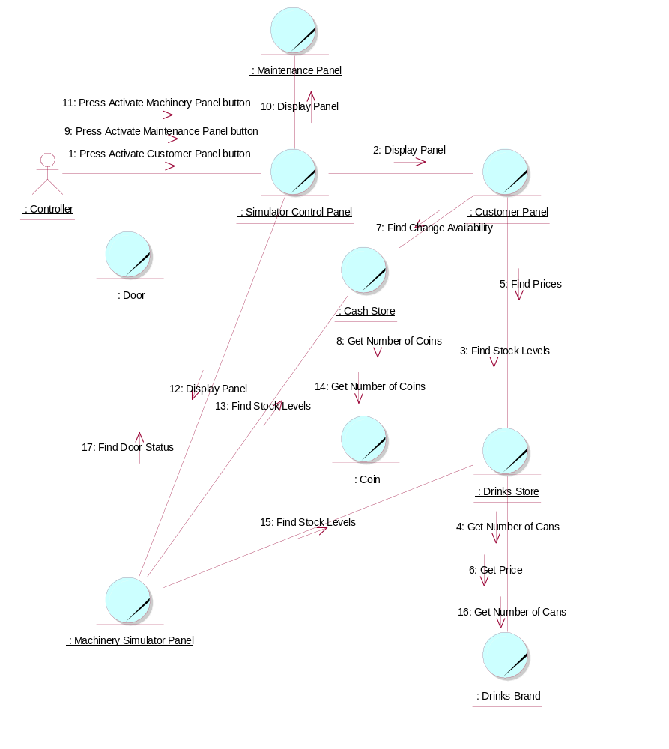

Participating Objects
: Cash Store
This is the repository for all Coins entered into the system. It is also where all change given to the Customer is taken from.
: Coin
The object stores the characteristics of coins entered into the system.
: Controller
This actor represents the controller of the VMCS simulation. Hence it is only present in the simulated system (ie: this project) and would not be an actor of the target implementation. In particular, it performs several of the physical activities (ie: those that can not be provided by software) that are undertaken by the Maintainer in the target implementation, which include maintaining drink stocks and cash stocks inside the vending machine.
: Customer Panel
This panel simulates the vending machine's customer interface panel. It will enable the user (the Customer) to:
1 insert coins;
2 select brands;
3 terminate transaction.
It will also provide the following display functions:
1 display total money inserted;
2 indicate coin not valid;
3 indicate no change available;
4 display the value of the change to be collected;
5 display an icon representing the dispensed drink.
: Door
This is the door of the vending machine. This is opened so that the Maintainer can re-stock the machine.
: Drinks Brand
This object stores the characteristics of the types of drinks can held in the system.
: Drinks Store
This is the repository for the drinks cans held by the system.
: Machinery Simulator Panel
This panel simulates the physical actions of the maintainer. It enables the user to:
1 display and enter new values for the number of cans of each Drinks Brand held by the Drinks Store;
2 display and enter new values for the number of Coins of each denomination held by the Cash Store;
3 display whether the vending machine Door is unlocked, and enable it to be locked.
: Maintenance Panel
This panel simulates the vending machines maintainer control panel. It will enable the user (the Maintainer) to:
1 log-on using a password;
2 display number of Coins of each denomination in the Cash Store;
3 display total value of cash in the system;
4 display number cans of each Drinks Brand held in the Drinks Store;
5 change the price of any Drinks Brand;
6 collect all cash held in system;
7 formally exit from the panel.
: Simulator Control Panel
This panel is displayed when the system is started up. It enables the user (the Controller) to :
1 start (switch on);
2 stop (switch off);
3 activate the customer panel;
4 activiate the maintenance panel;
5 activate the machinery simulator panel.

Class Diagrams

Domain Class Diagram: Set-Up Panels
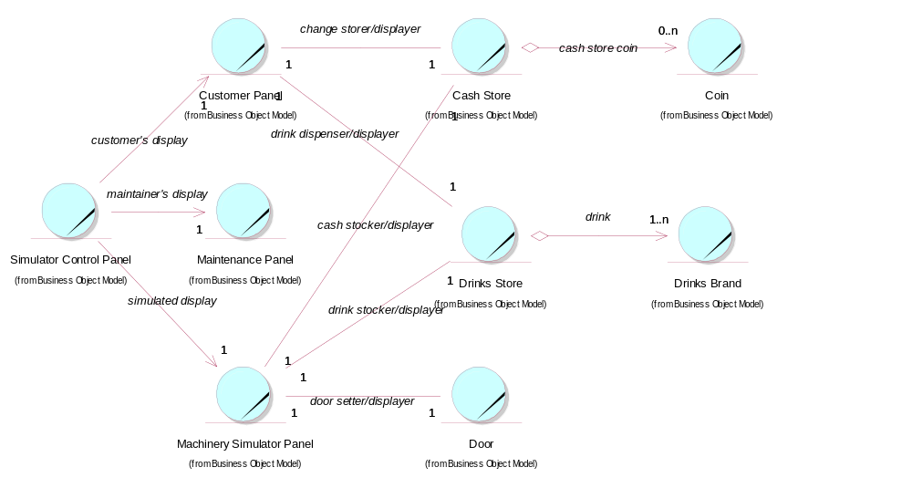

Derived Requirements
The Customer Panel, Maintenance Panel, and Machinery Simulator Panel should have the format specified in figures 3, 4 and 5 respectively of "User Requirements Specification for Vending Machine Control System (VMCS) Computer Simulation", reference ISS/VMCS/TR.1.

